SCIENCE NEWS RELEASE
FOR IMMEDIATE RELEASE
Contact: R. Marion Bliss
MA Journalism and Public Affairs
Media Liaison, Senior Science Writer
Science News Service™
239-289-5823 cell
May 31, 2020
By Rosalie Marion Bliss
www.ScienceNewsService.com
Contact: rmarionbliss@gmail.com
Fabrics Charge Up Filtering Efficiency of Cotton Used in Face Masks
Multiple layers of specific combinations of every-day fabrics were found to provide excellent filtration efficiency (FE), particularly when it came to the smallest aerosolized particles emitted during speech. The new study suggests that, in the right combination and layers, with no gapping around the perimeter, cloth face masks could indeed help reduce viral transmissions. The study was authored by scientists with the University of Chicago and Argonne National Laboratory in Lemont, Illinois.
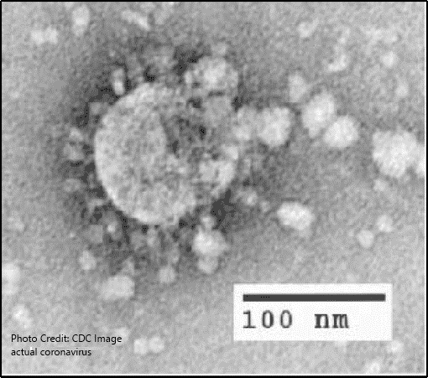
Viral transmission is heightened when individual carriers—with or without symptoms—are in close contact indoors for tens-of-minutes, to a half hour, and longer. Experts recommend continuing physical distancing at 6 feet, even with a face mask. Sensitive laser lights have been used by NIH scientists to observe thousands of invisible oral fluid droplets emitted per second during speech. Particles smaller than 300 nanometers become aerosolized, or temporarily airborne, when emanated while talking. For context, one millimeter is about half the side of a nickel—yet there are 1 million nanometers in a millimeter.
The researchers found that using one layer of 600-thread-per-inch (TPI) cotton combined with two layers of specific chiffon provided filtration efficiency of 97% for temporarily airborne particles less than 300 nanometers (nm) wide—and 99.2% for heavier particles greater than 300 nm wide. See the chart of top four performers.
N95 respirators are engineered to filter particles larger than 300 nm in diameter, which are mostly non aerosolized—by a rate of 95% or more. In testing the 15 fabric-combination samples, the researchers used an aerosol generator (to mimic airflow during speech) that is widely used for testing face respirators’ compliance with The National Institute for Occupational Safety and Health (CDC-NIOSH).
Another combination that was a top performer was one layer of 600 TPI cotton combined with 1 layer of specific flannel (95% FE).
Critically, all masks, regardless of makeup, to be effective, must not have gapping around them while worn. Just one gap in any face mask diminishes efficiency by as much as 50%. Engineers and others have designed face mask patterns, some with fitting features, as seen on YouTube, and provide tips on making darts that help remove gaps in cloth face masks.
​ Worse performing filtration efficiency, researchers noted, were "fabrics that are porous, which should be avoided". This would include thin or single-layered coverings of loosely woven cotton materials. Even quilters cotton, marked 80 threads per inch, or TPI, provided less than 50% filtration when double layered, according to the findings.
The high-filtration rates of the top-performing samples, out of the 15 tested, were likely due to their combined effect of both mechanical and electrostatic-based barrier and filtration, explained the researchers. This refers to the static electricity sometimes felt when handling polyester nits. "Polyester woven fabrics can retain more static charge compared to natural fibers or cotton due to their lower water adsorption [adherence to surface] properties," according to the study. Thus, instead of working with 100% cotton flannel, they chose flannel that included 35% polyester.
The study was headed by Dr. Supratik Guha at Chicago’s Pritzker School of Molecular Engineering. The research findings were published in NANO April 24, 2020. While the study did not specifically test for protecting the wearer vs. others: “It is my belief that the barrier of protection can go both ways to a degree, says Dr. Guha. "But that question still needs to be studied to know for sure. It should be made clear that cloth masks are no substitute for N95 masks.” The reason a mask can prevent transmission from the mask wearer is that large aerosol droplets get caught inside the mask fabric before they have a chance to spew and evaporate into smaller droplets that would have become temporarily suspended in air.
​ There has been limited research data on the performance of various commonly available fabrics used in making cloth masks--more studies are coming out now.
Face mask safety is increasingly important as the CDC updated its guidance May 5, stating “Everyone should wear a cloth face cover when they have to go out in public, for example to the grocery store or to pick up other necessities.” CDC issued further guidance May 27 on how to safely wear and take off cloth face coverings to help mitigate the pandemic (cdc.gov/coronavirus). ​
Further cloth face mask research should focus on masks that fit with zero gaps, the role of repeated washing, and humidity arising from exhalation, according to the UChicago/Argonne scientists. ##END TEXT, ART-CHART AND OPTIONAL SIDEBAR BELOW##

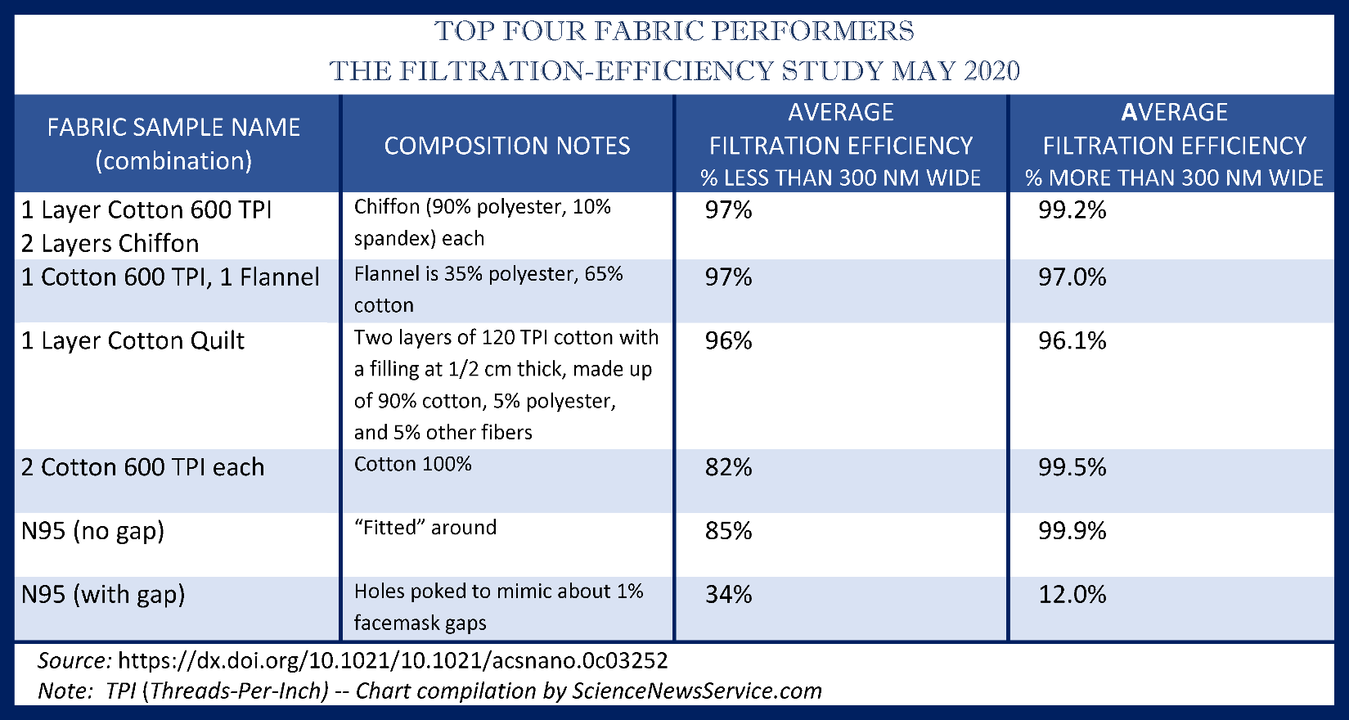
The researchers limited their study measurements to droplets sized from 10 to 10,000 nanometers (nm) wide, which is the respiratory virus transmission range. Droplets temporarily go airborne when particles are sized from 10 to 300 nm wide in diameter. Corona-virus particles are about 100 nm in diameter per image below.
To help relate, one millimeter is about half the side of a nickel—yet there are 1 million nanometers in a millimeter.

PARTICLES GO AIRBORNE AT UP TO 300 NM WIDE FOR 10 MINUTES AND MORE

